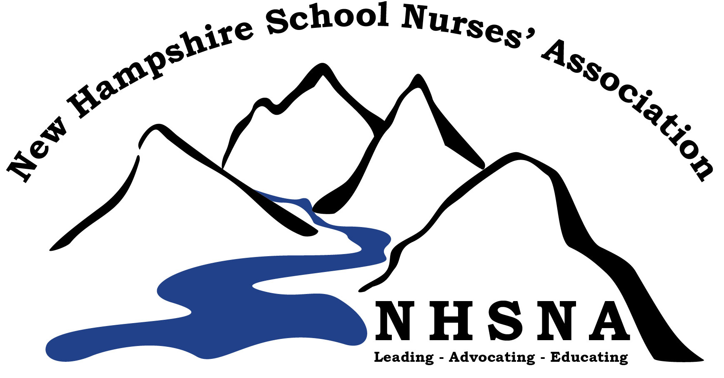

New Hampshire School Nurses’ Association
2017-2018 School Nurse of the Year Nomination Form

INSTRUCTIONS: Complete the nomination packet to include the Nomination Form, reference letter(s), and curriculum vitae. Please print and mail the originals to: Kathy Barth, School Nurse, Crossroads Academy, 95 Dartmouth College Hwy, Lyme, NH 03768, postmarked no later than February 1, 2017.

Nurse’s Name and Credentials: Click here to enter text.

Home Address: Click here to enter text.

Employer’s / School Name: Click here to enter text.

Employer’s Address: Click here to enter text.

Home Phone Number: Click here to enter text.

School Phone Number: Click here to enter text.

Present Position: Click here to enter text.

Grade Levels Served: Click here to enter text.

Number of Years in Present Position: Click here to enter text.

Number of Students Served: Click here to enter text.

Supervision of Additional Staff: Click here to enter text.

Total Number of Years in School Nursing: Click here to enter text.

National School Nurse Certification? Yes ☐ No ☐

Active member of New Hampshire School Nurses’ Association (required) Yes ☐ No ☐

Active member of National Association of School Nurses Yes ☐ No ☐ Don’t Know ☐

Nomination Submitted By: Click here to enter text.

Position: Click here to enter text.

Date Submitted: Click here to enter a date.

Phone Number: Click here to enter text.

Email: Click here to enter text.

New Hampshire School Nurses’ Association
2017-2018 School Nurse of the Year Nomination Form

In the space provided, please explain how this candidate demonstrates a leadership role in the following topic areas:

PROVIDER OF CARE: (examples may reflect clinical knowledge and skills; nursing process; provider of client confidentiality and respect; provider of client advocacy; communication skills- written, verbal and non-verbal)
Click here to enter text.

PROGRAM MANAGEMENT: (Examples may reflect development of school and/or community projects; planning and assessment of school services; development and implementation of national, state and district policies; collaborator in student care; involvement in the development and implementation of Individualized Health Plans (IHPs), Individualized Education Plans (IEPs), and 504 plans)
Click here to enter text.

HEALTH EDUCATION: (Examples may reflect provider of continuing education to the school community; participation in curriculum development; staff wellness; counseling; teaching; and resource facilitator)
Click here to enter text.

PROFESSIONAL DEVELOPMENT: (Examples may reflect participation in continuing education opportunities; membership in and/or service to local, state, and/or national professional organizations such as National Association of School Nurses (NASN), American Federation of Teachers (AFT), National Education Association (NEA), American Nurses Association (ANA), New Hampshire School Nurses’ Association (NHSNA))
Click here to enter text.

COMMUNITY INVOLVEMENT: (Examples may reflect development of school and/or community projects; involvement in political and legislative efforts)
Click here to enter text.

RESEARCH: (Examples may reflect contributions to school nurse literature or professional publications; participation in or utilization of nursing research in daily practice)
Click here to enter text.

