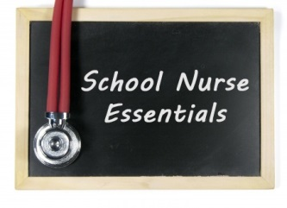
School Nurse Essentials

New Hampshire School Nurses’ Association

Friday, March 10, 2017

Concord Country Club

22 Country Club Lane Concord, NH

8:00 – 3:30 6 contact hours

8:00 – 8:30 | Pre-Conference Breakfast and Registration  A full breakfast buffet will open at 8:00
8:30 – 9:45 | Welcome and Introductions  Nancy Wells, MSN, NCSN  School Health Coordinator, NHDOE  Legislative update, School Nurse Certification Update,  Advocating using Tools from NHSNA and NASN
9:45 – 10:00 | School Nurse Partnership Program  Max Puyanic CEO, ConvenientMD
10:00 – 11:00 | Assessment of the Ear  Dr. Jeffrey Collins  Chief Medical Officer, ConvenientMD  ** Bring your Otoscope for hands on practice
11:00 – 11:15 | Break: Beverages Provided
11:15 – 12:15 | Asthma and Auscultation of the Lungs  Dr. Jeffrey Collins  Chief Medical Officer, ConvenientMD  ** Bring your Stethoscope for hands on practice
12:15 – 1:00 | Lunch: Provided by Concord Country Club
1:00 -- 2:00 | School Nurse Role in Emergency Management  Barbara Pamboukes M.Ed., BSN, RN  Portsmouth School District, 2002 President, NHSNA
2:00 – 2:45 | School Wellness Programs  Roberta Abodeely, BS RN  Nashua School District
2:45 – 3:15 | Taking Care of Ourselves: Wellness for Us  Abigale Pelletier BSN, RN  Hanover School District
3:15 – 3:30 Evaluations: Questions and Answers

