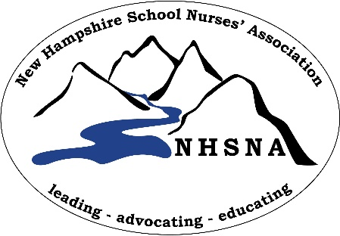
New Hampshire School Nurses’ Association
Vendor / Supporter Application
Spring Conference April 7th, 2018
Margate Resort 76 Lake St. Laconia NH

Organization Name: | Click or tap here to enter text.
Name of Representative: | Click or tap here to enter text.
Address: | Click or tap here to enter text.
Email Address | Click or tap here to enter text.
Cell Phone | Click or tap here to enter text.

Our Organization is interested in sponsoring the NHSNA at the following level:
All exhibitor tables include breakfast and lunch for one, and table cloth.

☐ Donating an Item or a basket of items for a raffle
☐ $125.00 Non-Profit Exhibitor
☐ $250.00 Business Exhibitor
☐ $1000.00 Conference Sponsor, invitation to be a 15 minute guest speaker, 1 exhibitor table with meals for two provided and recognition on all advertising as a
sponsor.
☐ Meals (Breakfast and lunch) for 2nd person @ $50 each _____________

Do you need electricity at your booth? YES NO
REGISTRATION AND PAYMENT IS ONLINE AT https://nhschoolnurses.org/event-2800725
Invoices will be emailed to you that you can either pay online, or send a check. Instructions will be on the invoice. The NH School Nurses Association is a 501(c)(3) organization.

If you have any questions, please email us at nhschoolnurses@gmail.com
Thank you for your support!

