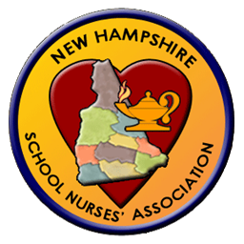
New Hampshire School Nurses’ Association
Sponsor/Supporter Application
Spring Conference April 1th, 2017
SERESC 29 Commerce Drive Bedford, NH 03310

Organization Name: | Click or tap here to enter text.
Name of Representative: | Click or tap here to enter text.
Address: | Click or tap here to enter text.
Email Address | Click or tap here to enter text.
Phone | Click or tap here to enter text.

Our Organization is interested in sponsoring the NHSNA at the following level:
☐ Donating an Item or a basket of items for a raffle
☐ $250 .00 Sponsorship of a conference speaker and recognition as a supporter
☐ $500.00 Sponsorship of a conference speaker, exhibitor table will be provided, and recognition as a supporter
☐ $1000.00 Sponsorship of conference break, invitation to be a guest speaker, exhibitor table will be provided and recognition as a supporter.
☐ $2500.00 Sponsorship of conference meal, invitation to be a guest speaker, exhibitor table will be provided and recognition as supporter on NHSNA webpage.
☐ Other ___________________________________________________________________

Please return this form and check (made payable to NHSNA) to:
HeatherAnn LaBier, RN
Hillsboro Deering High School
12 Hillcat Drive
Hillsboro NH, 03244
(603)-464-1290 Fax 464-3842

www.nhschoolnurses.org
nhsna@comcast.net

The NH School Nurses Association is a 501(c)(3) organization.
We will send you a confirmation with additional information by email. Thank you for your partnership!

