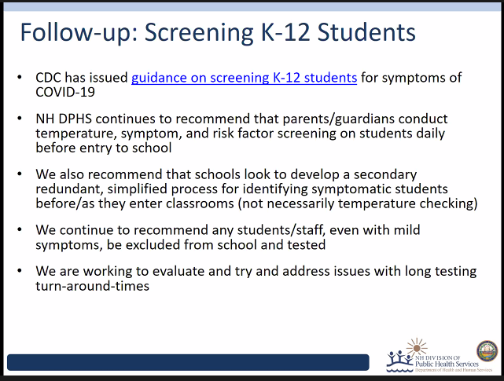

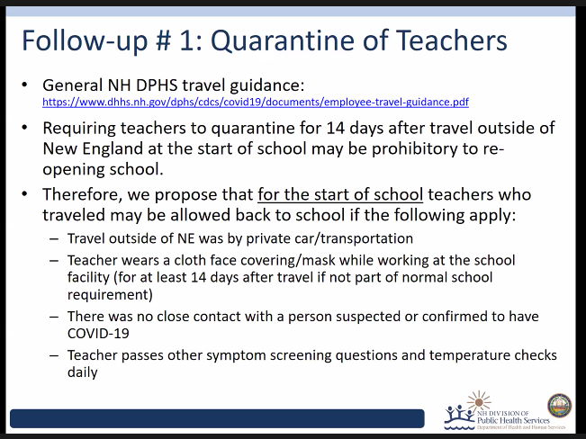

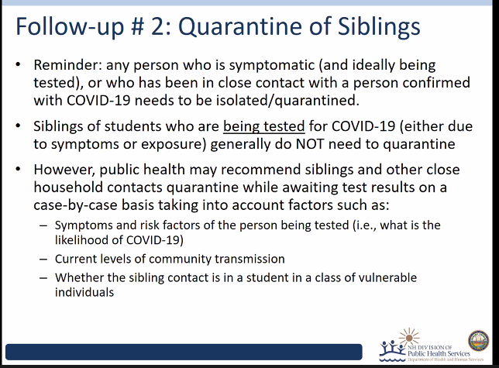

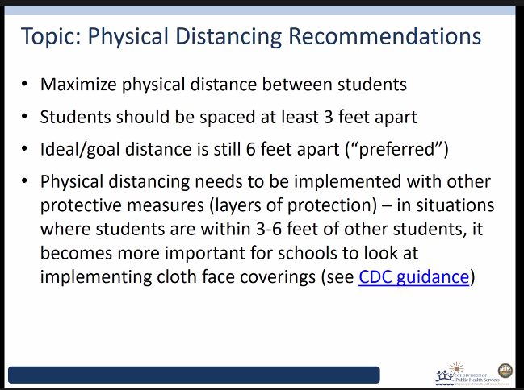

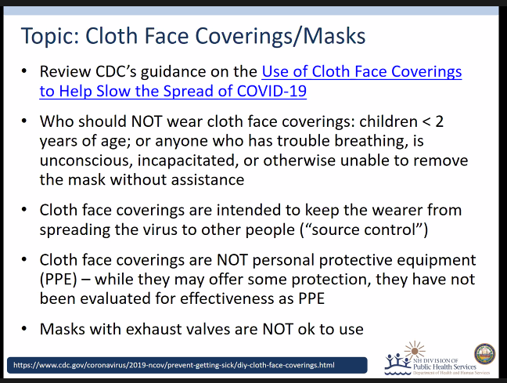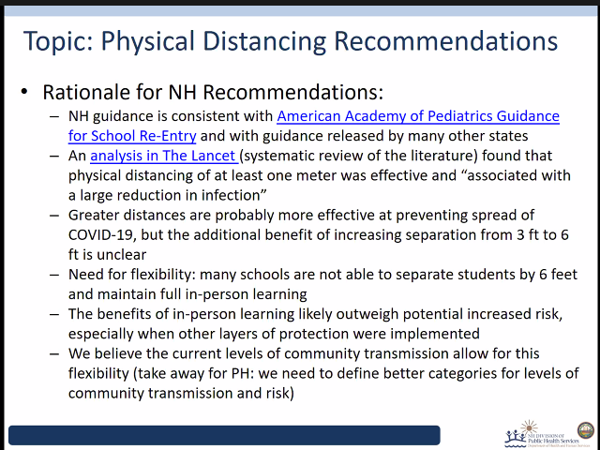

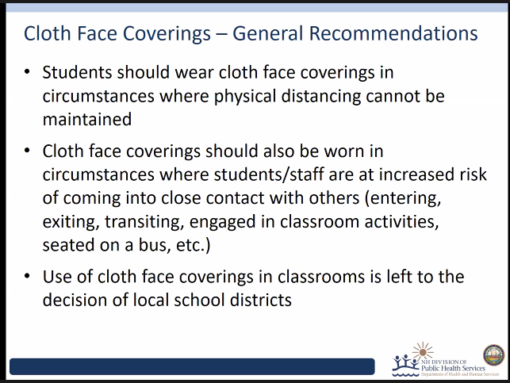

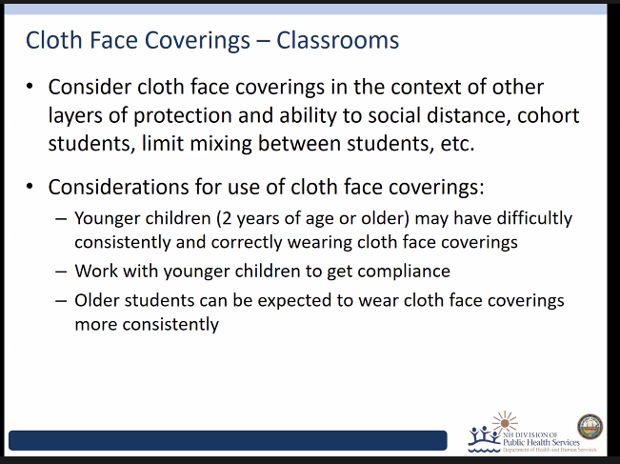

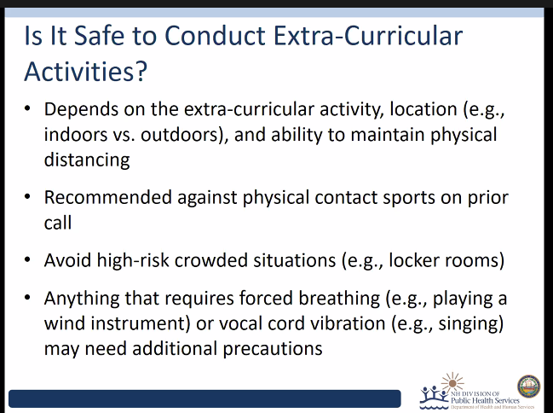

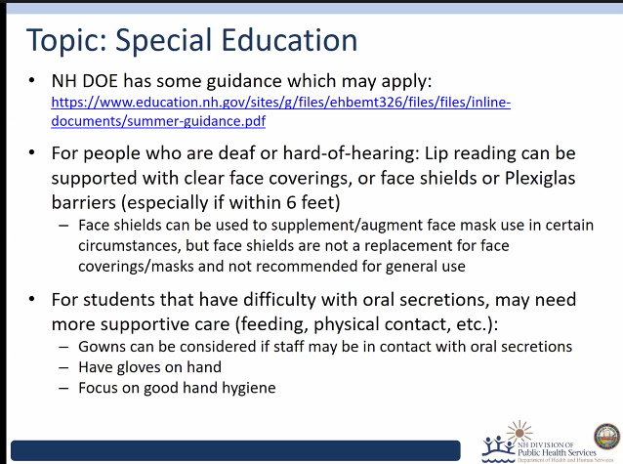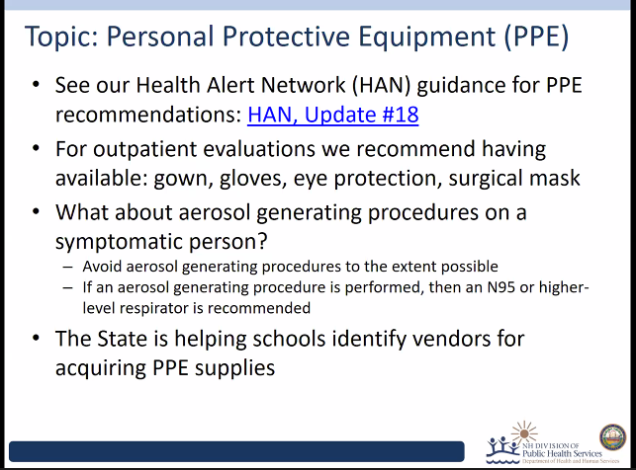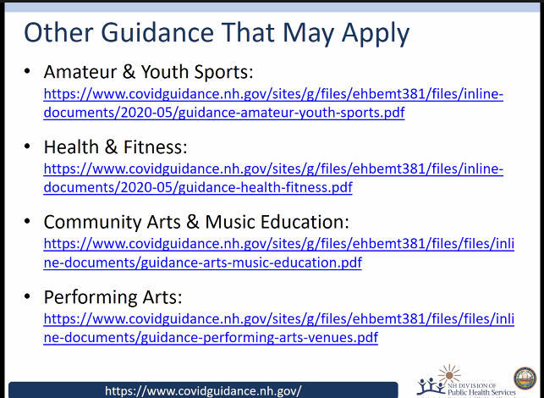

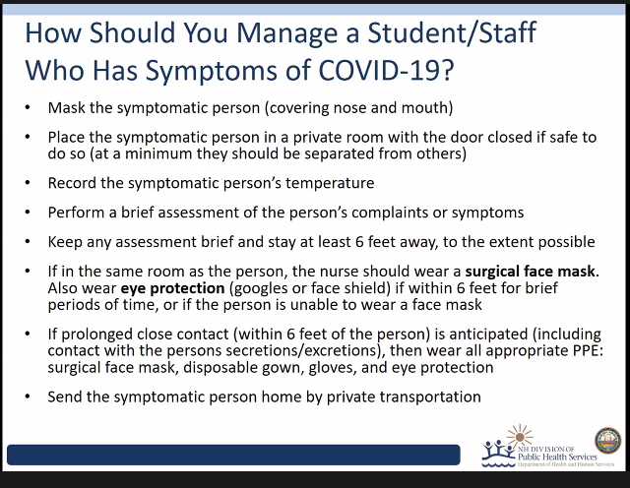

Maria Butler 11:59 AM
Am I correct in thinking that if a child is sent home with symptoms and is tested, if the test comes back negative then the child is able to return to school when feeling better and has no fever?
Laurie Foster 12:00 PM
Where can we get fitted for and purchase a N95 mask?
This question has been answered live
Maria Butler 12:01 PM
is this in writing anywhere so we have it to refer to with our staff?
elizabeth.a.talbot 12:07 PM
The guidance for schools? Yes. Online on DOE website.
pbegonis 12:03 PM
will the DHHS send out guidelines for the school nurses to follow
elizabeth.a.talbot 12:05 PM
Yes, the full guidance is out. We are responding to requests for algorithms and additional guidance by creating more tools that we will circulate and modify as needed.
mccarrons 12:04 PM
Guidance on mask breaks throughout the school day. Students wearing masks all day. Eating and drinking, I know, for how long and when?
Thanks
elizabeth.a.talbot 12:06 PM
I suggest simply as short as possible. When masks are off, it will be helpful to pay attention to seating (facing same direction, 3-6 feet apart) and enabled hand hygiene will be important.
mpalm 12:04 PM
Considering the recent news of children 5 and younger having large viral loads in their nasal passages do you recommend that PreK and K students wear a mask while at school?
elizabeth.a.talbot 12:09 PM
It is emerging data that young children have more RNA on average than older counterparts (not infectious virus necessarily), yet we also have data that children do not seem to transmit as efficiently as older adolescents and adults. So hard to reconcile this emerging data. Again, masks when safe, hand hygiene for all, screen out ill persons no matter the age.
Erin Gauthier 12:05 PM
Faculty and staff are inquiring if shared eqpuipment like zerox machines should require a sign / out process etc.
elizabeth.a.talbot 12:10 PM
Hand hygiene before use of shared equipment, and cleaning frequently touched surfaces using routine methods will go a long way here. I am not aware of the utility of a strategy to sign out if those strategies are being embraced.
jwyman 12:05 PM
what is the difference between wearing a cloth mask vs a surgical mask? When it come to a positive student in a class. When dterming who needs to quarantine?
elizabeth.a.talbot 12:12 PM
Cloth and surgical masks both are appropriate for source control (that is, reduce transmission from the wearer to those around). We do not take the wearing of masks into account for decisions around quarantine. There are good reasons for that, but beyond the space here. NOTE masks with exhale valves are NOT appropriate for source control.
Meryl Levin 12:05 PM
Related to maria’s question - are we able to require that both a negative test AND improvement of symtoms before they are able to return?
elizabeth.a.talbot 12:13 PM
Even if COVID-19 is ruled out (whew!), there are other infectious diseases (pertussis, flu), so usual rules for back to school apply.
mccarrons 12:05 PM
Masks off for how long and when not eating or drinking?
elizabeth.a.talbot 12:14 PM
Case by case. Most people can tolerate all day without problem, while others (with COPD, asthma, anxiety) may need more breaks. The goal is full time, the reality is we have to flex.
sam ewing 12:05 PM
What recommendations do you have re: shared materials used by young elementary school students in the classroom?
elizabeth.a.talbot 12:17 PM
I believe there are tricks of the trade offered in the school guidance, but in general this virus does not survive well on objects (fomites). In principle, reduce use of shared objects, especially those that cannot be easily cleaned. Designate some objects to each child as feasilble. And, same theme, enable good hand hygiene after handling shared objects.
mclark 12:05 PM
Could you please review the changes from the CDC guidance in regards to health and illness exclusion?
elizabeth.a.talbot 12:17 PM
I beleive Dr. Chan has just answered that.
Jean 12:05 PM
Is the family refuses to test then do they need to isolate for 10 days.
elizabeth.a.talbot 12:19 PM
That is the ideal. It may depend on your risk analysis of the child - is the illness compatible with COVID or their usual asthma, were they in contact with a confirmed case, can you help them facilitate cost free testing? For the latter, we are hoping to create systems for such. More on that later.
Jackie 12:05 PM
What is the protocol for face shields? Ok for teachers or just used for PPE for nurses?
elizabeth.a.talbot 12:22 PM
We understand there are several circumstances appropriate for face shields in your settings. Although face shields are appropriate for healthcare workers working in settings where rates of COVID exceed 50/100,000 for example, perhaps these are appropriate if a person cannot tolerate face masks (COPD, asthma, etc), or cannot maintain distance from others who are with tracheostomies and potentially shedding respiratory secretions, or those who have to read lips and you cannot find the clear face masks. Those are examples that come to mind.
jessicaw 12:05 PM
Where can we find the guidelines?
Lindsay Pierce 12:08 PM
The State of New Hampshire Department of Education Reopening Guidance can be found here: https://www.covidguidance.nh.gov/sites/g/files/ehbemt381/files/inline-documents/sonh/k-12-back-to-school.pdf
Melanie Leathers 12:06 PM
will you address the new CDC guidelines for screening/exclusion that was released this past week?
elizabeth.a.talbot 12:23 PM
Dr. Chan did do this. We are well aware of the new CDC guidance and are adapting to our own context (epidemiology, resources, capacity). All guidance is dynamic (except maybe hand hygiene!) so stay tuned as we continue to read, learn, adapt.
Kim Hamilton 12:06 PM
How can we get a copy of this recorded meeting?
Lindsay Pierce 12:09 PM
We are working to determine a manner in which to share the recording and will share through the NH School Nurse Association and DOE when available.
Jennifer Rocheleau 12:06 PM
Is the guidance posted on the DHHS website?
Lindsay Pierce 12:08 PM
The NH Department of Education Reopening Guidance can be found here: https://www.covidguidance.nh.gov/sites/g/files/ehbemt381/files/inline-documents/sonh/k-12-back-to-school.pdf
mpalm 12:06 PM
What is the recommendation for cleaning of our Isolation Rooms at school after use?
Lindsay Pierce 12:23 PM
Please find the CDC Guidance on disinfection here:
https://www.cdc.gov/coronavirus/2019-ncov/community/clean-disinfect/index.html
alanney 12:06 PM
regarding staff who will be working with and diapering or toileting students some of these students might not be wearing masks. I plan on these staff wearing, surgical masks, shields while with student, and adding gowns and gloves for toileting and diapering. Gowns and gloves will be single use. Do you have any other suggestions? Is Covid in stool or urine an issue?
elizabeth.a.talbot 12:26 PM
COVID-19 SARS CoV-2 viral RNA has been recovered from stool, and there has been very few identifications of full virus. However there has NEVER been evidence of transmission to anyone else from stool. Contact precautions are always appropriate when dealing with someone else's body secretions/excretions (think norovirus, rotavirus, salmonella etc).
Anonymous Attendee 12:06 PM
Please clarify the use of air conditioning within schools, if already in place, may they be used? teachers are asking as to whether they may bring their own units
elizabeth.a.talbot 12:27 PM
More ventilation is better. Outdoor air is best, appropriate placement of fans (directing the flow of air person's exhalation to another person), cleaning filters, optimzing HVACs outside air enrichment, etc. Dr. Chan already mentioned a nice new guidance from WHO just this morning.
jwyman 12:06 PM
I know close contact is being within 6ft for 10 mins. Is that cummaltive throughout the day or per interaction?
elizabeth.a.talbot 12:28 PM
Cumulative, but we are here to help with these complicated decisions. We have whole rooms full of trained teams to help you apply these guidelines. Can call 271-4496, although we hope you never have to!
Lyme EOC 12:06 PM
Did I hear and understand correctly last week that a decision to close a school that might be having an “outbreak” would be informed by the DHHS input in following the test positive children with the school nurses.
elizabeth.a.talbot 12:30 PM
Yes, in general, this is our role, our expertise. We are here to help in these difficult public and community health decisions. Confirmed or suspected cluster of illness warrants a call to us 271-4496.
Dinah O'Neil 12:06 PM
If students are seated 6' apart in the classroom, should they still wear masks?
elizabeth.a.talbot 12:30 PM
Yes, that is the ideal.
Nora Portnoy 12:07 PM
How will the State help the nurses obtain PPE? 3m will not sell it to use even though we are nurses. Prices on Amazon and other sites are ridiculous and burning through our budgets. Even though we do not work in hospitals, we are nurses and caring for others
elizabeth.a.talbot 12:32 PM
The intention is you identify your usual routes for acquisition, and this may require some new partnerships (such as local healthcare settings). I have heard that the State stockpile is prioritized for caring for patients in the healthcare settings. Dynamic space, so continue to let us know your realities for acquisition.
Lisa Therrien 12:07 PM
Lots of questions about AC units in windows and if that is allowable or not. Thoughts?
elizabeth.a.talbot 12:32 PM
Yes, under current guidance. Outside air is good!
Liberty Ebright 12:07 PM
We will be utilizing a pod system at our school to limit interaction between students. If one student in a pod tests positive, how long do other students in his/her pod need to quarantine?
elizabeth.a.talbot 12:34 PM
Sounds like a good idea, to create these cohorts. If there is a confirmed case or suspected cluster, we can help you identify those who are contacts for 14 day quarantine. So if there was not close contact, if everyone was masked, using hand hygiene, brief time of potential of exposure . . . lots of features would help us work with you to take these decisions.
mpalm 12:07 PM
Where can a school nurse have their N95 mask fit tested and how often should it be tested?
elizabeth.a.talbot 12:35 PM
Is it possible to partner with a local hospital for that? Or do you have access to an Occupational Medicine Office?
Nan Soule 12:07 PM
Why is a N95mask be given to a student that has symptoms? What is the problem with the vented masks?
This question has been answered live
Bobby Kelly 12:08 PM
thank you all, the text of these q&a is very helpful. any chance we can share the transcript of these to all attendees at the end of the meeting?
Lindsay Pierce 12:18 PM
Thank you for this suggestion. We are currently in the process of creating a FAQ document for schools and these questions will be included in that document. We will post to our website and also share through the NH School Nurse Association when available.
jessicaw 12:11 PM
Do we have the school nurse guidance?
elizabeth.a.talbot 12:36 PM
The School guidance provides much of these principles, plus we are developing additional guidance such as response to a symptomatic child and will circulate imminently.
Karen Freedman 12:12 PM
Hi! Thank you for this presentation today!
Lindsay Pierce 12:18 PM
Thank you for joining us!
Phil Alexakos 12:12 PM
Travel outside of NE---Does this apply to other businesses?
Lindsay Pierce 12:16 PM
The employee screening and excusion criteria can be found here: https://www.dhhs.nh.gov/dphs/cdcs/covid19/documents/employee-travel-guidance.pdf
Elizabeth Lacasse 12:14 PM
Can you please address the differences between CDC guidelines for student return to school and NH DHHS return to school. If this is different can NH DHHS provide a document to send out to parents as to why we will be stricter than the CDC guidelines?
elizabeth.a.talbot 12:36 PM
As above in 3 other questions.
caroline hanly Rn 12:14 PM
If there is a student on a school bus who is symptomatic do we need to quarantine the other students on the bus
elizabeth.a.talbot 12:37 PM
Case by case. Depends on the social and travel distance.
Jackie 12:16 PM
Is a runny nose or congestion still a reason for exclusion?
elizabeth.a.talbot 12:37 PM
Yes if those symptoms are new and not explained by a chronic underlying illness.
Meryl Levin 12:17 PM
Can you address students/staff with allergies or documented history of migraines. I Understand the doctor’s note for pre-existing conditions is needed BEFORE the symptoms show, but the next steps? When symptoms present, suggest they see a doc, require negative test and doctor’s note? Suggestions?
elizabeth.a.talbot 12:38 PM
If you have reason to trust the report, I believe you can just make a note of that and help the child/staff develop a statement on screening that 'this is my normal chronic underlying condition'.
mccarrons 12:20 PM
Thank-you for this presentation and answering our questions!
Lindsay Pierce 12:21 PM
Thank you for joining us!
Cathleen Burbee 12:24 PM
Is the updated information on quarantine after travel for teachers/staff who do so by private car etc and may return to school with masking true for someone who travels now and retruns to New England such as return to work?
Lindsay Pierce 12:29 PM
Current General Travel and Quarantine Guidance and Employee Screening and Exclusion Criteria may be found here: https://www.dhhs.nh.gov/dphs/cdcs/covid19/documents/employee-travel-guidance.pdf
Lisa Therrien 12:28 PM
Can you send a link here for the WHO guidance around AC units please.
Lindsay Pierce 12:31 PM
https://www.who.int/emergencies/diseases/novel-coronavirus-2019/question-and-answers-hub/q-a-detail/q-a-ventilation-and-air-conditioning-in-public-spaces-and-buildings-and-covid-19
You 12:30 PM
Are portable/personal air coolers safe for use in classrooms?
Are portable/personal air conditioners safe for use in classrooms?
Can teachers have fans facing out the window in order to move air out of the classrooms?
You 12:31 PM
Do the NH public health experts recommend portable filtration systems (i.e. HEPA filtration units) for isolation areas in school health offices? Would these be contraindicated?

Not sitting on floor: Able to disinfect and keep social distancing easier. Can you control the physical distancing of students.

Fomites: shared items / assignments coming from home on papers: no credible transmission documented of surface contamination. Highlight hand hygiene
NYT article, child tested and high levels of RNA; finding RNA is not the same thing as finding infectious virus.

