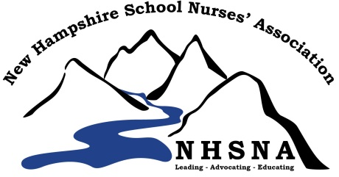
Scholarship Application
New Hampshire School Nurses’ Association
www.nhschoolnurses.org nhschoolnurses@gmail.com

General information:
A limited number of scholarships are available yearly for NH School Nurses. The scholarship is not to exceed half the cost of the course or $500.00. Reimbursement will be made after applicant sends verification of successful course completion.

All three criteria below must be met in order to qualify:
1. A NHSNA member for at least two years.
2. Currently active in the practice of school nursing.
3. Use the scholarship for accredited course work toward a nursing- related degree.

How to apply: Complete application below and email it to nhschoolnurses@gmail.com

Application Deadline: April 1, 2022

Notification: All Applicants will be notified in writing if they are qualified by May 31, 2022. First time applicants will have priority.

Date of Application: Click here to enter a date.
Name: Click here to enter text. Telephone: Click here to enter text.
Address: Click here to enter text. Work Phone: Click here to enter text.
Email: Click here to enter text.
RN License Number: Click here to enter text. NHSNA Member since year Click here to enter text.
Course Title: Click here to enter text.
Course Location: Click here to enter text.
Course Dates: Click here to enter text. Course Credits: Click here to enter text.
Course Cost: Click here to enter text. Amount Requested: Click here to enter text.

