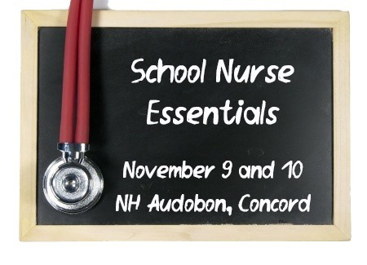
Saturday Attendees will receive a FREE copy of
School Nursing: Scope and Standards of Practice, 3rd Edition is by school nurses for school nurses, who often can be the only healthcare provider in an educational setting. Bridging those two worlds is but one distinctive challenge of this nursing specialty.
Saturday Nov 10, 2018
8:30 to 3:45 5.25 Contact Hours
McLane Audubon Center
84 Silk Farm Road, Concord, NH
Breakfast and Lunch Included

New Hampshire School Nurses’ Association
SCHOOL NURSE ESSENTIALS

Leading – Advocating – Educating

8:30-9:00 | Pre-Conference Breakfast and Registration  A light breakfast buffet will be open at 8:30
9:00-9:15 | President Welcome  Kathy Barth BSN, RN, NCSN
9:15-10:15 | Overview of School Nursing Scope and Standards  Linda Compton MS, RN  NASN Delegate, New Hampshire School Nurses Association
10:15-10:30 | Break
10:30-11:30 | Working With Homeless Children and Families  Talley C. Westerberg LICSW Winnacunnet High School
11:30-12:15 | Lunch Provided
12:15-1:15 | DCYF Reporting  Talley C. Westerberg LICSW Winnacunnet High School
1:15-2:15 | Special Education Overview  Nancy Wells, APRN, MSN
2:15 – 2:30 | Break
2:30 – 3:00 | Asthma and Bronchodilators Care Plan Development  Martha Judson RN
3:00 – 3:45 | Glucagon and Diabetic Care Plan Development  Kerri Reynolds MSN, RN Plymouth State University

