8:30 – 9:00 | Pre-Conference Breakfast and Registration  Light breakfast buffet will be open at 8:30
9:00- 9:15 | President Welcome
 | Kathy Barth BSN, RN, NCSN
9:15-10:15 | Immunization Update
 | Suzanne Allison NH DHHS Immunization Program
10:15-10:30 | Break - Light Refreshments provided
10:30-11:30 | Delegation in the School Setting  Tracey Collins
11:30-12:15 | Lunch
12:15-1:15 | Hearing Screening  New England Audiology
1:15-2:15 | Medicaid to Schools  Laurie Vachon Interim Administrator MTS NH DHHS
2:15-2:30 | Break - Light refreshments provided
2:30-3:45 | Emergency Medications and Care planning (TBD)

New Hampshire School Nurses’ Association
School Nurse Essentials
Leading – Advocating – Educating

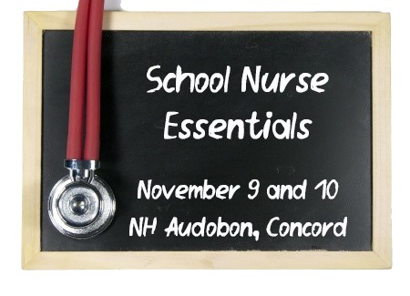

Friday, November 9, 2018 5.25 Contact Hours
McLane Audubon Center
84 Silk Farm Road, Concord, NH
Breakfast and Lunch Included

