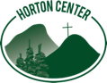
Attention School Nurses: Horton Center Wants You!!

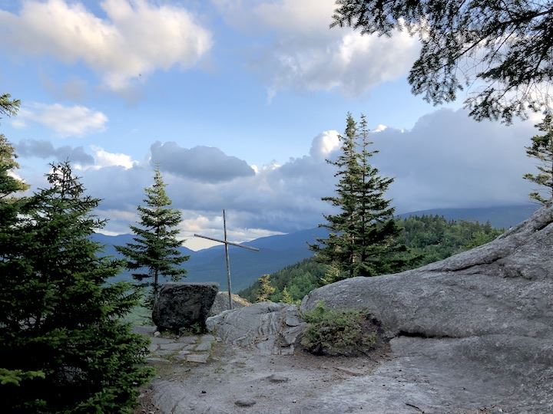

Come spend a week at Horton Center this summer in the fresh Mountain air!
Horton Center is a small, United Church of Christ (UCC), ACA accredited church camp on top of Pine mountain in Northern New Hampshire, in the town of Gorham.
Located in the White Mountain National Forest, we run week-long sessions for kids (grades 3- 12) and some sessions for families and adults, with an average number on site of 30-50 people. The nurses quarters are simple but comfortable with a private bedroom, bathroom, and treatment room/office all in the same building. The small, dedicated Summer Staff are helpful, friendly and WFA certified.

NOTE: We are planning to open in-person this summer with testing and other COVID19 precautions and practices in place. We really want you to join us for a week… or more!

We still need nurses for the following weeks this summer:

July 3 – 10
July 10 – 17
July 17 – 24
July 24 – 31
July 31 – Aug. 7

These are one week, paid positions for Nurses with a current NH license (LPN or higher) or a Compact License, and it includes room and board onsite. Salary is based on experience and degree. Nurse’s children may be eligible for free enrollment at camp! Nurses arrive Saturday afternoon and depart the following Saturday morning. The campers come Sunday afternoon and leave Saturday morning.
Come be a part of this, beautiful, vibrant camp for a week. You’ll be glad you did!

Please contact Executive Director Tim Hughes at:
thughes@nhcucc.org or 603-545-9660

Visit our website to find out more about us: www.HortonCenter.org

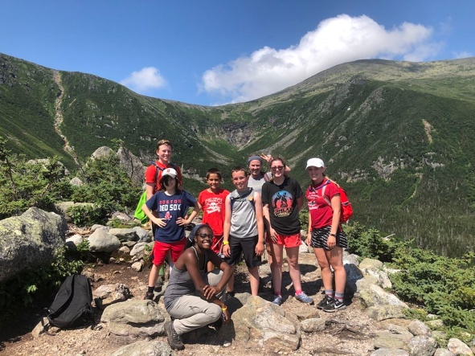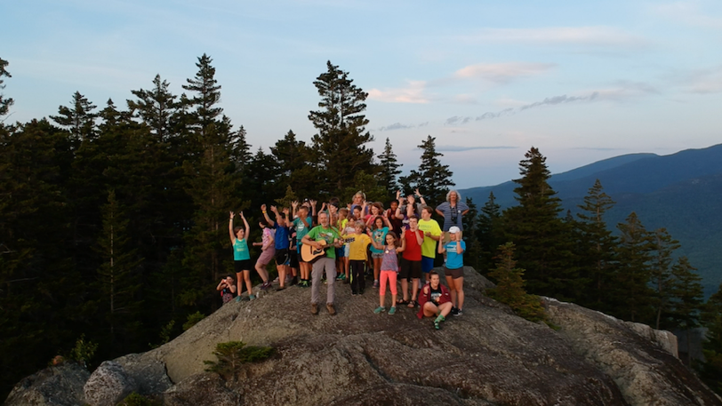
Horton Center is owned and operated by the New Hampshire Conference of the United Church of Christ

