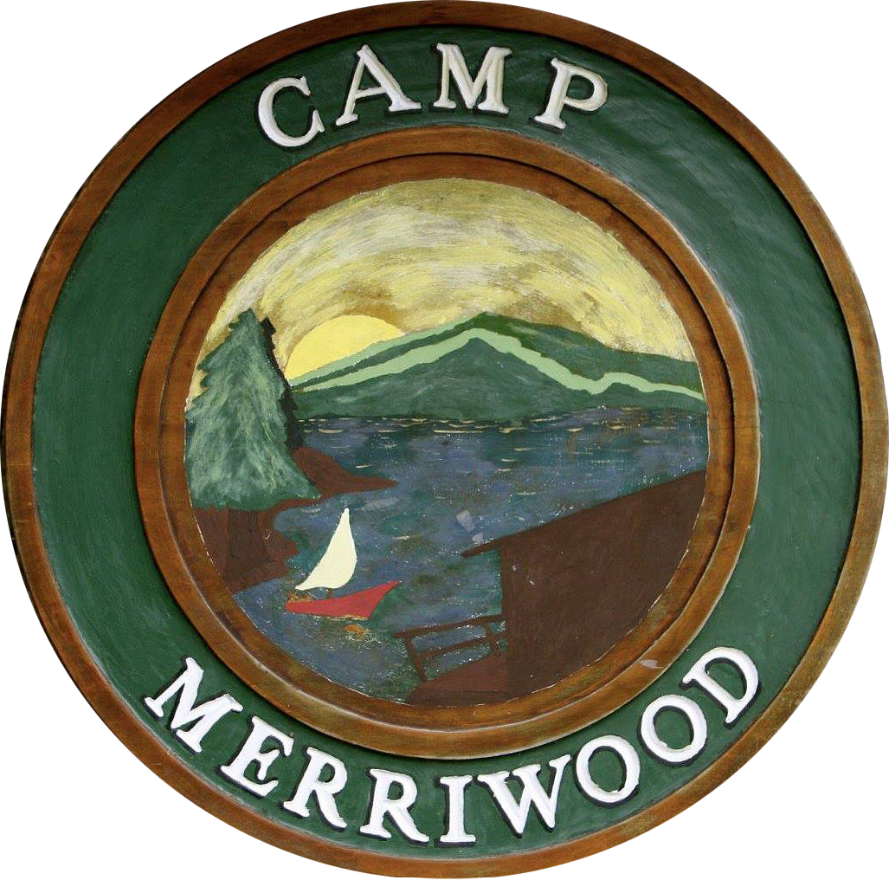
Every girl has a voice, a talent, a caring heart which will shine and prosper when given an appropriate stage.

Orford, New Hampshire, foothills of the White Mountains
SUMMER 2017 Nursing OPPORTUNITY

Do you like having fun and working with kids? Do you have a passion for helping others? Do you enjoy spending your summer days outside? Do you want to make lifelong friendships with others from around the world?

If this sounds like you, come join us at Camp Merriwood, a 4, 3, and 7 week girls sleepaway camp. Merriwood is looking for RN’s who are interested in being a part of our medical staff. The following are some of the activities we offer to our campers:

*Soccer *Softball *Basketball
*Golf *Tennis *Rock Climbing
*Volleyball *Track & Field *Waterskiing
*Lacrosse *Gymnastics *Horseback Riding
*Swimming *Dance *Arts & Crafts

- MERRIWOOD: Merriwood is a family run camp with the third generation as directors. Its campers and staff are drawn from around the world.

- JOB DESCRIPTION: Our nurses oversee all aspects of health care for the camp community including: response to emergencies, injuries and illness; distribution of medications; maintenance of the health center and record logs; communication with parents regarding health concerns; decisions and appointments regarding visits to town doctor.

- JOB REQUIREMENTS: Nurses should be friendly, compassionate, team-oriented, hard-working and detail oriented. Current RN or ARNP license by the State of New Hampshire. The ability to relate effectively to children, parents and college-age staff is essential.

- HOW TO APPLY: If you are interested, please apply online at www.merriwood.com or contact Susan Miller Hild, (860) 561-9527.

