The following packet includes the State of New Hampshire’s protocol and tool kit for school nurses in combating acute respiratory illness, as well as instructions for school nurses on how to report influenza-like-illness daily online. This information has been made more easily accessible through separation of various sections listed below:

Content of Protocol

Guidance on Acute Respiratory Illness……………………………...……………………Page 2-3

Reporting Absenteeism in Schools……………………………………………..…………Page 4-5

Prevention....................................................................................................................……Page 6-7

List of Reportable Diseases…………………………………………………………….……Page 8

Content of Toolkit

Letter to School Nurses………………………………………………………...……………Page 9

Letter to Parents (English and Spanish)………………………………………...………Page 10-11

Posters and Handouts…………………………………………………………...………Page 12-18

**Guidance on Acute Respiratory Illness for Elementary and Secondary Schools**

**November 15, 2017**

**NH Department of Health and Human Services (NH DHHS) Objective:**

* Protect yourself, family, friends and the community from Acute Respiratory Illness.

**Recommendations for students and staff:**

* To maintain general health and hygiene activities in your school. Instruct and remind students and staff to carefully wash hands using soap (and or use alcoholic based hand sanitizer if not visibly soiled). Encourage the importance of coughing and sneezing into the elbow. In addition, remind everyone not to share drinks or utensils with one another.
* Teaching regarding proper hand washing techniques should be conducted twice every school year.
* School officials should ensure that soap, paper towels, and hand sanitizer are readily available and well stocked. Frequently touched surfaces should be cleaned regularly.
* Any student presenting respiratory symptoms *such fever/chills, coughing, sore throat, runny or stuffy nose, general malaise, headaches, muscle aches, vomiting, or diarrhea* should contact a health care provider.
* Ill individuals should avoid public places and only leave home in case of emergency or to seek medical attention (i.e., pharmacy, clinical visit).
* If ill individual or caretaker needs to leave their home, protective measure should be implemented (i.e., face mask, tissues, or handkerchief) to cover all cough and sneezes.
* Students and staff recovering from respiratory illness should be symptom free for at least 24 hours prior to returning to school. It is recommended that individuals see a health care provider before returning.
* School nurses should report higher than normal absenteeism to NH DHHS Communicable Disease Section 603-271-4496, or utilize the reporting website (Additional Information on Page 3).
* Please use attached parent letter template as an informational tool.

**Caretakers:**

* Should remain home if they develop symptoms, minimize contact in the community, and designate a single household member as caretaker to minimize illness transmission.

**For any Questions regarding the contents of this message, please contact NH DHHS Communicable Disease Control and Surveillance Section 603-271-4496 (after hours 603-271-5300). Also refer to NH DHHS website for more information**

**Introduction**

School-aged children are one of the populations at the highest risk for developing acute upper respiratory infections. Their immune systems are still developing, while physical contact and exposure to other children makes the spread of these infections rapid and prevalent. Children spend the majority of their days in school, so enacting proper prevention and treatment measures can decrease the spread and severity of upper respiratory infections (URI).

Although there are several types of upper respiratory infections, the common cold and the flu are the most predominant URIs children experience, leading to more school absences and primary care provider visits than any other illness. These viral infections are spread by direct or indirect contact with droplets from an infected person that sneezes, coughs, or talks. Those who become infected are contagious 1 day before symptoms even appear, and up to 7 days after. Flu-like symptoms include fever, cough, sore throat, nasal congestion, muscle aches, headache, fatigue, vomiting, or diarrhea.

**Case Definition**

In the event of increased respiratory illnesses, case definition inclusion might consist of any or all of the following symptoms: myalgia (aches), headache, chills, fatigue, sore throat, sneezing, dry or productive cough, rhinorrhea (runny nose), and nausea accompanied by vomiting or diarrhea. Influenza-like-illness, in particular, may present with fever (temperature above 101°F (38.3°C) orally, above 102°F (38.9°C) rectally, or 100°F (37.8°C) or higher taken axillary.

**Outbreak Report**

By New Hampshire state statute RSA 141-C, many communicable respiratory diseases and related positive laboratory results are reportable. Additionally, state statute requires that any suspect outbreak, cluster of illness, or any unusual occurrence of disease that may pose a threat to the public’s health must be reported to the NH Department of Health and Human Services, Bureau of Infectious Disease Control (BIDC) within 24 hours of recognition.

Reports may be made by phone to the BIDC at (603)-271-4496 or toll free at 1 (800)-852-3345, extension 4496. After normal business hours or weekends, the phone report should be made to the Public Health Professional on-call through the NH Hospital switchboard at 1 (800)-271-5300 or toll free at 1 (800)-852-3345, extension 5300.

The BIDC will work closely with the contact person (school nurse or principal) to control the outbreak. Usually this requires:

* A school floor plan that includes all classrooms/wings/floors.
* A Public Health Professional will be in contact with the school to establish methods for identifying and counting cases, clarify and update specific case definitions and exclusion periods and will be responsible for coordinating the exchange of information between the school and the BIDC.
* Absenteeism surveillance data: please utilize this website link to report absentee surveillance to the state. (<https://business.nh.gov/Influenza/InfluenzaReporting.aspx>)

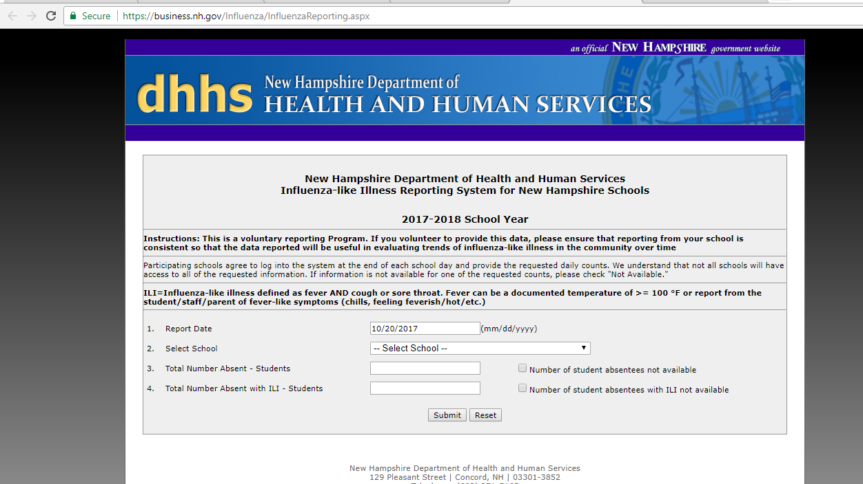

**Outbreak Investigation and Reporting**

Absenteeism surveillance is the systematic collection and analysis of student absence data. This data should differentiate between absenteeism rates due to illness or from other causes. Data describing student absences due to illness may be used to monitor disease trends and to detect and respond to clusters and outbreaks. Implementing an effective absenteeism surveillance system is key to preventing acute respiratory illness in the student population.

Having an abnormally large absenteeism level identifies a respiratory illness outbreak. This level is often identified by the school health office surveillance system. Nurses should record the following information on the initial outbreak investigation form (Appendix A):

* Total number of student at the school
* Number of ill students
* Number of students with current Acute Respiratory Illness outbreak symptoms
* Total number of staff at the school
* Number of ill Staff (If known)
* Number of ill staff with current Acute Respiratory Illness outbreak symptoms (If known)
* Date of disease onset for first recognized case
* Presenting disease symptoms
* Hospitalization and/or death among cases

In reporting acute respiratory illness it is essential to designate a school contact personnel (e.g., school nurse, principal) who responsible for disseminating absenteeism information. All schools should be outfitted with an available floor plan that outlines classrooms, wings and floors. And finally that designated personnel should contact the NH Department of Health and Human Services, Communicable disease.

For further information refer to the CDC website [www.cdc.gov](http://www.cdc.gov) or the NH DHHS website at [www./dhhs.nh.gov](http://www./dhhs.nh.gov).  Or call the NH DHHS Communicable Disease Control Section at 1-603-271-4496- or 1-800-852-3345 ex.4496.

**NH Epidemiology:**

Estimating the number of upper and lower respiratory tract infections in New Hampshire (NH) is difficult, as the vast majority of these infections is not etiologically defined and is not reportable. Therefore, the annual number of cases cannot be calculated for many viral and bacterial respiratory infections.

The *NH Communicable Disease Surveillance Report* includes the following information on reportable respiratory illnesses during the last five years. *YTD Jan 1, 2017- Aug 31, 2017

|  |  |  |  |  |  |  |
| --- | --- | --- | --- | --- | --- | --- |
| ***Disease*** | ***2012*** | ***2013*** | ***2014*** | ***2015*** | ***2016*** | ***2017 YTD\**** |
| *Haemophilus Influenzae*, invasive disease | 113 | 224 | 224 | 222 | 223 | 18 |
| *Streptococcus Pneumoniae*, invasive disease | 882 | 1101 | 996 | 9101 | 996 | 72 |
| Legionellosis | 222 | 227 | 112 | 331 | 229 | 52 |
| Pertussis | 2267 | 1131 | 884 | 441 | 660 | 50 |
| Tuberculosis | W9 | 115 | 111 | 113 | 115 | 17 |

**Prevention and Response:**

Recommendations to decrease respiratory illness in schools include:

* Maintain general health and hygiene activities in your school. Remind all students and staff of the importance of covering their nose and mouth with a tissue when coughing or sneezing (or coughing or sneezing into their sleeve if tissues aren’t available). Frequent hand washing with soap and water, or using alcohol-based hand sanitizers, should be promoted in your school.
* Display posters in the school to promote hand hygiene. Hand washing posters can be downloaded from the CDC website at: <https://www.cdc.gov/flu/protect/habits.htm>
* Identify ways to increase social distances (the space between people). If possible, move desks further apart, rotate teachers between classrooms while keeping the same group of students in one classroom, or postpone class trips.
* Maintain good ventilation in shared school areas (e.g., open windows, keep air duct system clean, etc).
* Ensure that school staff takes steps to routinely clean and disinfect surfaces in the classroom (e.g., doorknobs, desks, keyboards). Schools can use standard products according to directions on the product label and per school protocol. Additional information can be found at: <https://www.cdc.gov/flu/school/cleaning.htm>
* Provide education about symptoms, mode of transmission, and prevention to parents, students, and staff.
* Remind those attending school and family members to assess, each morning, all people around them and especially all school-aged children for symptoms of respiratory illness.
* Encourage all students, staff, and faculty with respiratory illness to stay home and not attend school.
* If staff notes a student with visible signs of respiratory illness upon arrival at school the following should occur:
  + Isolate the child from other children.
  + Have the child wear a surgical mask if tolerated.
  + Limit the number of people who come into contact with the child.
  + Adults in contact with an ill child should use a surgical mask and continue to wash hands frequently.
  + Contact a parent or guardian and request the child be picked up as soon as possible.
  + Inform the parents or guardian about symptoms observed in the child and what is required for the child to return to school (See Case Definition Section).
  + Ask the parent or guardian to relay observations made by school staff to the child’s primary health care professional.



**Letter to Parents (English and Spanish)**

Dear Parent,

Flu season is approaching. We are asking for your help to prevent the spread of flu in our school. The flu spreads from person to person and children in schools are among the most affected. We want to keep the school open during the flu season and we cannot do it without you. Here are a few ways to help:

* **Know the signs of the flu**: Signs may be fever greater than 100 degrees, cough, sore throat, body aches, headache, and feeling very tired. Some people may also vomit or have diarrhea.
* **Keep sick children at home**. Children should stay at home for at least 24 hours after the last signs of a fever without the use of medicine. They should not return to school within 24 hours of the last sign of vomiting or diarrhea. Those who have a constant cough should stay home until medicine relieves it. Any child that is sick at school should go home.
* **Report their absence to the nurse**. If your child is out sick with the flu or flu-like illness, please let the nurse know.
* **Teach your children to wash their hands**. Hand washing with soap and water or using hand sanitizer is the best way to reduce the spread of germs.
* **Teach your children to cover their coughs and sneezes** with a tissue or their elbow.
* **Teach your child not to share personal** items like their food or water bottles.

Our school works closely with the Bureau of Infectious Disease Control (BIDC) to monitor flu events. For more information, [*see the attached flyer/additional information and*] and visit www.flu.gov, or call 1-800-CDC-INFO for the most current information about the flu. We will notify you of any changes to our school’s plan to prevent the spread of the flu this season.

Sincerely,

[*School administrator’s name and signature*]

Querido Padre,

La temporada de gripe se acerca. Pedimos su ayuda para prevenir la propagación de la gripe en nuestra escuela. La gripe se propaga de persona a persona y los niños de la escuela son los más afectados. Queremos mantener la escuela abierta durante la temporada de la gripe. Aquí hay algunas maneras de ayudar:

* **Sepa los signos de la gripe:** Incluye una fiebre más de 100 grados, la tos, dolor de garganta, dolor corporal, jaqueca, y sentir muy descansado. Algunas personas vomitan o tienen diarrea.
* **Mantenga a los niños enfermos en casa**. Los niños deben quedarse en casa por lo menos 24 horas después de los últimos signos de fiebre sin la medicina. No deben volver a la escuela dentro de 24 horas de los últimos signos de vomita o diarrea. Los niños con tos constante deben quedarse en casa hasta la medicina la alivie. Algún niño que está enfermo en la escuela debe irse a casa.
* **Informe a la enfermera si su niño se queda en casa**. Si su niño está ausente de la gripe, comunique con la enfermera por favor.
* **Enséñeles a sus hijos a lavarse las manos.** Lavado de manos con agua y jabón o desinfectante de manos es la mejor manera de reducir la propagación de gérmenes.
* **Ensénales a sus hijos a cubrirse la boca cuando tosen** con su codo o un tejido.
* **Ensénales a sus hijos a no compartir artículos personales** como la comida o botellas de agua.

Nuestra escuela colabora con El Departamento de Salud y Servicios Humanos de Nuevo Hampshire para observar los eventos de la gripe. Para más información, *[vea al volante adjunto/ más información y*] visite [www.flu.gov](http://www.flu.gov), o llame 1-800-CDC-INFO para la información más actual de la gripe. Le notificamos sobre algunos cambios al plan de la escuela a para prevenir la gripe esta temporada.

Sinceramente,

*[Nombre del administrador de la escuela y la firma]*

August 24, 2017

Address Block

Dear School Nurse:

School administrative staff and nurses are valuable members of any school system and are often the first to note unusual levels of absenteeism. High levels of absenteeism may indicate the presence of a larger health event in the community for which the New Hampshire Bureau of Infectious Disease Control (BIDC) can offer assistance in mitigating. When health events are identified early, students and staff can be connected to resources, such as fact sheets and recommendations for cleaning, in order to help students and staff return to a normal routine as quickly as possible.

School staff and nurses also play a critical role in managing connections between schools and healthcare providers or other agencies, as well as collecting and monitoring school health data, which may help inform efforts for preventing disease outbreaks.

To inform public health activities and response in New Hampshire, all public and private schools are asked to voluntarily report daily aggregate counts for student absenteeism and those absent with influenza like illness (ILI). If absenteeism due to ILI is not collected, schools can simply enter “0” or check the box indicating these data are not available.

The tool for reporting your school’s absenteeism data can be found at the following website: <https://business.nh.gov/Influenza/InfluenzaReporting.aspx>

No username or password is required and total time spent entering these data each day should be less than one minute. Your efforts will help identify health issues in the community, open a path to resources at BIDC should your school or community need assistance, and continue to strengthen the partnership between the Department of Education and the Department of Health and Human Services.

Please contact me with any questions or concerns. I can be reached directly at 603-271-5165 or [Kenneth.Dufault@dhhs.nh.gov](mailto:Kenneth.Dufault@dhhs.nh.gov).

Thank you for your continued support of public health.

Kenneth Dufault

Emergency Preparedness Surveillance Specialist

Bureau of Infectious Disease Control