August 7th, 2020 DHPS Noon Call for School Nurses
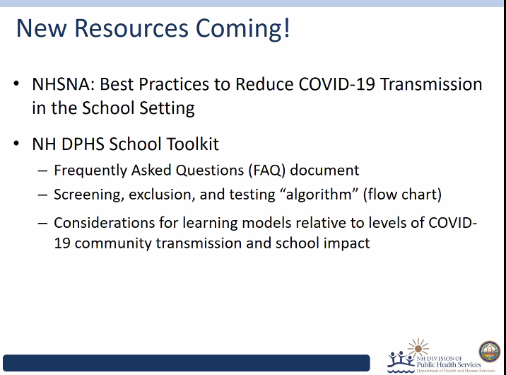
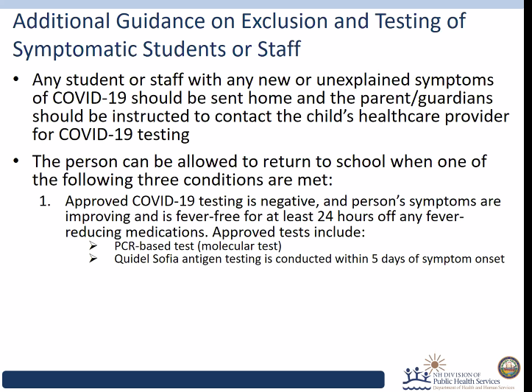

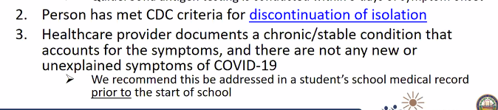
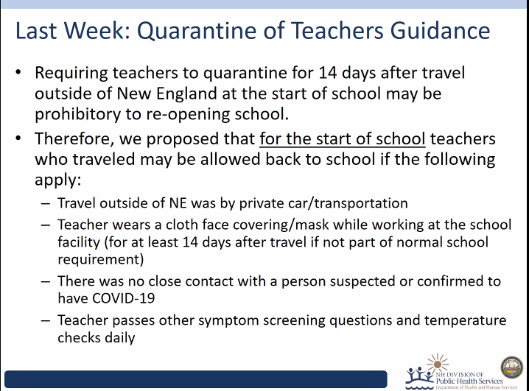
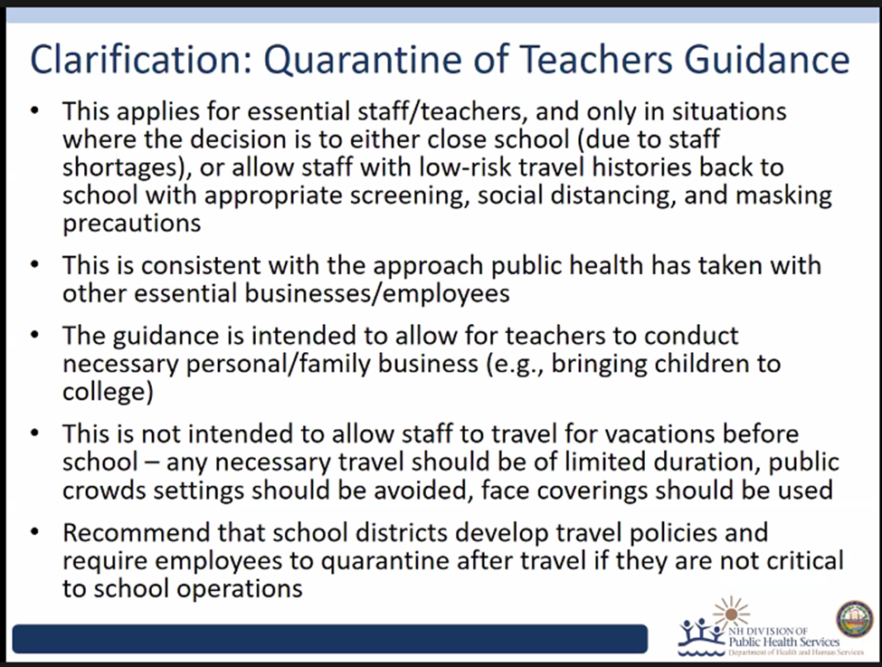

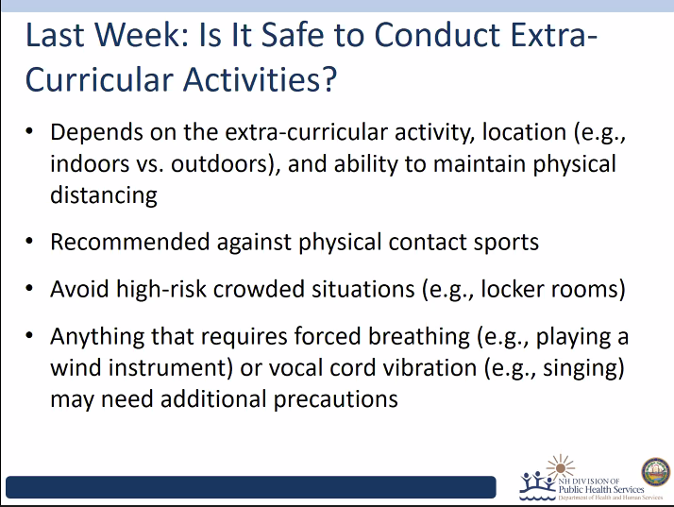

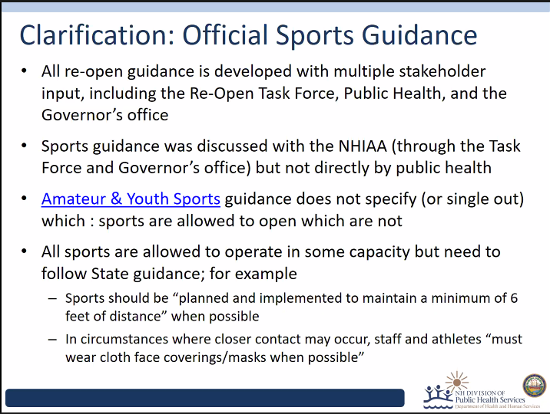

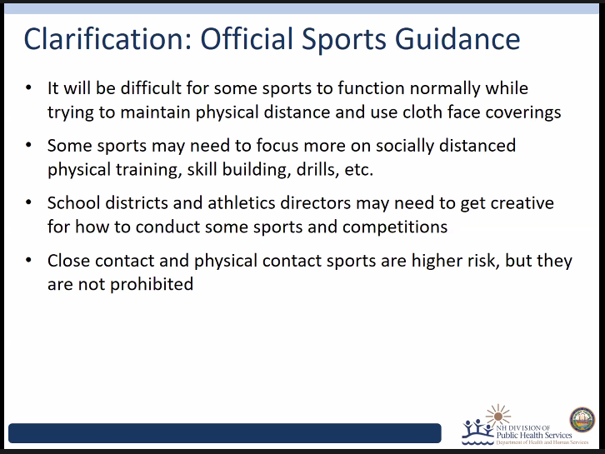

- If a child is not exhibiting any symptoms of illness, is it sufficient for paraprofessionals to wear a mask and gloves as PPE while working with their students at school?
  - Ben Chan would like to answer this question live.
- Will there be a flow sheet coming out for nurses to use for different scenarios, actions and return to school suggestions so that we are able to follow similar guidelines?
  - Elizabeth A. Talbot 12:03 PM YES! We are actively engaged in editing and revising with stakeholders. Coming soon, which Dr. Chan will mention in his deck. We had input into the NHSNA Best Practices Document

- What are the recommendations regarding suctioning in school?
  - Elizabeth A. Talbot 12:04 PM Suctioning respiratory secretions is a potentially aerosol generating procedure, which require higher level PPE to keep you safe. So N95 is more appropriate than a face mask, and eye protection, a gown and gloves are also appropriate.

- Where can we access previous recordings from previous meetings?
  - Beth Daly 12:04 PM Past meetings are not posted online. There is a webinar we hosted a few weeks ago that is available online at the DOE website here: https://www.education.nh.gov/who-we-are/commissioner/covid-19 NHSNA has posted the slides at nhschoolnurses.org
- Teachers are asking about turning in paper-daily journals etc. Is this ok with good handwashing?
  - Elizabeth A. Talbot 12:06 PM YES! This virus does not survive well outside the human body respiratory tract, and hand hygiene is an appropriate new normal for many of our daily tasks.

- What are your thoughts about middle and high school students using lockers?
  - Ben Chan would like to answer this question live.
- Are school children expected to wear masks during recess? What guidelines should be inplace for recess?
  - Elizabeth A. Talbot 12:07 PM We suggest universal masking when there is not certainty that the child will not maintain 6 weeks distance, as is the norm at most recess. Recall also the presence of frequently touched surfaces of jungle gyms etc also mean hand hygiene should be facilitated, enabled, encouraged.

- Are school kitchen staff able to remove masks while cooking in the kitchen area, with 3-6 ft distance between one another, and mask when serving children.
  - Beth Daly 12:06 PM They should wear masks. If they do not wear masks, it is very likely that if you have a confirmed case among kitchen staff, we will need to quarantine all of the kitchen staff because they would have spent more than ten minutes within 6 feet of one another.

- PPE supplies are really difficult to obtain. Please reconsider it being available through state.
  - Beth Daly 12:07 PM If a school has exhausted all options and cannot find appropriate PPE, they should contact the state for assistance.

- Would you provide source for why 24 hours is effective amount of time to return to school after symptom resolution?
  - Beth Daly 12:10 PM A summary of current evidence and rationale for these changes is described in CDC's Duration of Isolation and Precautions for Adults with COVID-19: https://www.cdc.gov/coronavirus/2019-ncov/hcp/duration-isolation.html
  - Elizabeth Talbot: 24 hours following resolution of fever following nonCOVID-19 respiratory illness is the longstanding recommendation that derives from what is known about typical nonCOVID-respiratory pathogen shedding, such as flu, adenovirus, rhinovirus, etc. However, COVID-19 (tested and positive or not tested and suspected) requires the 10/1 isolation before returning to school.

- Exactly which cloth face coverings will be allowed in schools. No bandanas, right. What about the cloth coverings that can be worn around the neck and pulled up to cover nose and mouth?
  - Elizabeth A. Talbot 12:12 PM This is delineated in the NHSNA guidance with preference to align as closely as possible to CDC guidance, such as multiply well fitted cloth face coverings, with single plies such as bandanas and gaiters usually being less effective.

- Are there state resources for obtaining PPE donations?
  - Beth Daly 12:11 PM If a school has exhausted all options and cannot find appropriate PPE, they should contact the state for assistance.
- Are paper bags the best place for childrens masks when not in use? Is pulling the mask down appropriate and safe to keep on the child’s neck while eating/taking a mask break?
  - Elizabeth A. Talbot 12:14 PM I have not seen guidance against the drop down approach, but in thinking it through, if it is contaminated with virus because of asymptomatic shedding, that virus has now been spread on skin beyond the face. I hope and expect that CDC has made the recommendation for the paper bags because they have thought that through and applied best practices to us.

- Parents have written to admin at our school wanting to know when we have a new positive case every time, even if their student is not a close contact. Like a general letter that goes out each time. What is DHHS recommendation/guidance?
  - Beth Daly 12:12 PM You will be receiving additional guidance on this from DOE/DHHS in the near future. Schools are always encouraged to establish transparent and regular communications with their communities as long as you are careful to protect individual privacy. Guidance is coming on this.
- What is the process when a student or staff member has a confirmed case of COVID? Who do we notify - Contact #?
  - Beth Daly 12:13 PM NH DHHS Bureau of Infectious Disease Control at 603-271-4496. We are available 24/7.
  - Lindsay Pierce 12:14 PM Please contact the NH Division of Public Health Services at 603-271-4496, or 603-271-5300 if after hours, and ask to speak to the Public Health Professional on call. You will find this number and directions in the newly posted FAQ.
- Are any children part of phase 3 vax trials? when do you, realistically, think they would vaccinated? when do you think we would reach a proper amount of herd immunity? at what level does the population need to have adequate herd immunity?
  - Elizabeth A. Talbot 12:17 PM I believe that one of the large phase 3 trials only is including children 16 and over. We continue to believe that by early winter we might have a safe vaccine for everyone. Modeling is being done to inform us what proportion of the population will need vaccination in order to drive R naught below 1 (when epidemic would peter out). We are hopeful and actively preparing for vaccine!

- What do we do in the situation if a parent/staff's partner travels for work outside of new england regularly? Should those students/staff in close contact with that person be home in isolation for 14 days.
  - Beth Daly 12:20 PM No the student/staff does not need to quarantine unless they themselves travel or the person who travels in the home becomes ill with COVID-19.

- If a child is not exhibiting any symptoms of illness, is it sufficient for paraprofessionals to wear a mask and gloves as PPE while working with their students at school?
  - Ben Chan would like to answer this question live.

- Will there be a flow sheet coming out for nurses to use for different scenarios, actions and return to school suggestions so that we are able to follow similar guidelines?
  - Elizabeth A. Talbot 12:03 PM YES! We are actively engaged in editing and revising with stakeholders. Coming soon, which Dr. Chan will mention in his deck.
- What are the recommendations regarding suctioning in school?
- Elizabeth A. Talbot 12:04 PM Suctioning respiratory secretions is a potentially aerosol generating procedure, which require higher level PPE to keep you safe. So N95 is more appropriate than a face mask, and eye protection, a gown and gloves are also appropriate.

