August 21, 2020
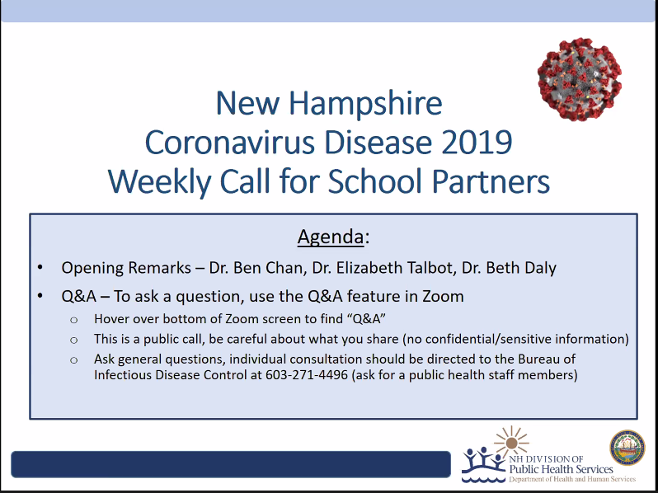

New cases or urgent calls should go to regular public health number

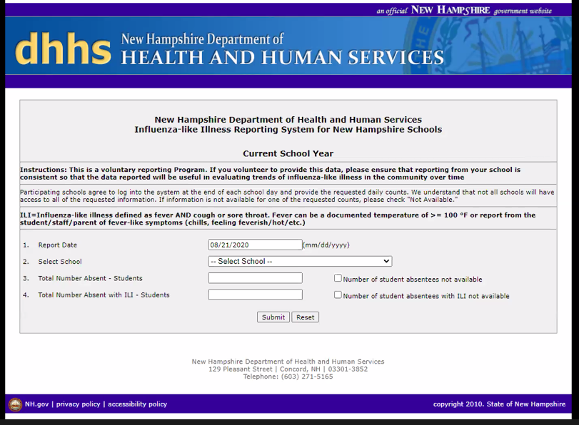

Coming by Next Friday, still a draft.
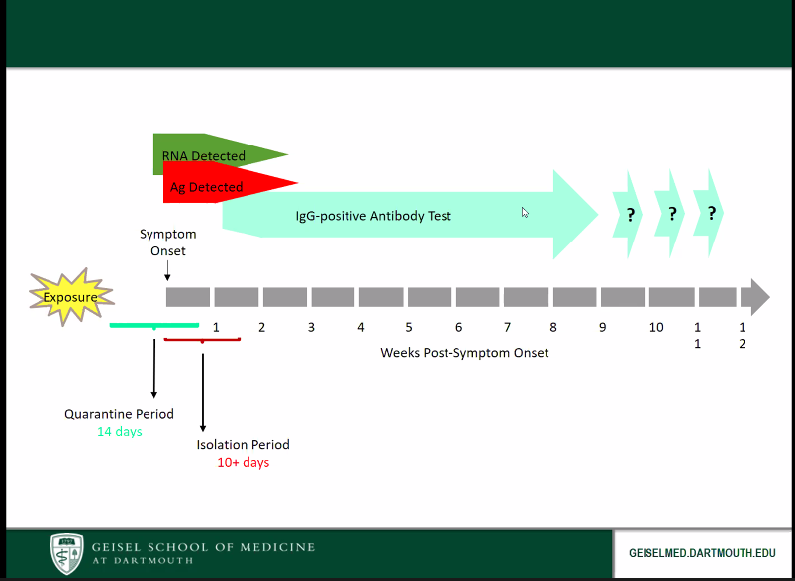

Erin Gauthier 12:01 PM
What parameters can be considered for student mask removal in the health office?
I’d like to create a couple relaxation pods were students can sit, relax without their mask on for approx.10 min when needed. I was planning to have the pods near windows, curtained off, and with a 3 foot marker for anyone else to respect.
Elizabeth Talbot 12:04 PM
This sounds like a good strategy, where the expectation is for universal masking, but if not tolerated for medical or emotional reason, then max distance, physical barriers, fresh air, and also include prominant pre and post hand hygiene as well.
Anonymous Attendee 12:02 PM
Would you please offer guidance for asymptomatic school nurses who are exposed to confirmed COVID-19? There are already too few nurses to adequately cover the numbers of students in need. With our historical shortage of school nurse substitutes, schools may be left with no nurse at all if one has to quarantine for 14 days.
HAN #10 links us to the CDC's criteria for return to work, but it was unclear to me whether or not the HCP needed to quarantine if they were fully outfitted in PPE (face mask, eye protection, gown).
https://www.cdc.gov/coronavirus/2019-ncov/hcp/guidance-risk-assesment-hcp.html
This question has been answered live
Laureen 12:02 PM
2. are there specific locations we should be sending symptomatic people for rapid testing?
Elizabeth Talbot 12:06 PM
There will be need for each school to identify local resources for testing. There are also online resources for statewide testing centers. See link at https://www.nh.gov/covid19/resources-guidance/testing-guidance.htm
Karen Utgard 12:02 PM
Sorry if this has been answered...are there recommendations regarding window AC units in classrooms?
Beth Daly 12:08 PM
See page 15: https://www.dhhs.nh.gov/dphs/cdcs/covid19/documents/covid-19-education-faq.pdf
Anonymous Attendee 12:03 PM
We have a special education student with an IEP that states must be in an air conditioned room when it is hot outside. The student also can not wear a face covering. Thoughts/ideas for staff and other students in the classrooms for their safety? Thanks!
This question has been answered live
Anonymous Attendee 12:03 PM
Going forward, would it be possible to schedule these calls at a time other than 12:00, as many of the school nurse participants are passing meds during this time.
Elizabeth Talbot 12:07 PM
Our schedule is so tight right now, but it may be that Sheryl can stand up a separate time for those for whom noon does not work.
erin stewart 12:03 PM
We are hearing that large practices (ie CH) are telling parents that kids do not need covid testing for mild URI symptoms. This is clearly in conflict with return to school guidelines. What is being done to make sure pcps are on same page as state and schools re: symptomatic testing and isolation.
Elizabeth Talbot 12:08 PM
We send HANs, we have a partners call Thursday noon, we reach out individually when we hear this is happening, we use media encounters for this, and will continue to promote this.
Karen Utgard 12:03 PM
One more- when moving a staff person or student to the isolation rooms- should the cloth face covering be exchanged for a surgical/ medical mask? thanks!
Elizabeth Talbot 12:09 PM
Spot on. Perfect.
Anonymous Attendee 12:04 PM
What are your thoughts on middle and high school students wiping their own desk and chairs before they leave the classroom?
Beth Daly 12:09 PM
This is a good idea.
Elizabeth Talbot 12:09 PM
Sounds acceptable if they can be observed to be doing it with appropriate care, thoroughness and disposing wipes appropriately.
JGanchi 12:04 PM
For districts with mandatory mask policy for students, what do you advise for student with medical exemptions not able to wear masks? Should the student not wearing a mask be segregated from their peers in a separate setting or are there other mitigating measures that schools should be considering?
This question has been answered live
Becky Wing 12:04 PM
We had been plannning on all students eating lunch in the classroom; however, some of our classrooms have less than 6’ of distancing. I am wondering if a plexiglass partition (3 sided on each student desk) would be an appropriate alternative to 6’ foot distancing while students eat lunch.
Elizabeth Talbot 12:11 PM
Yes, we are hearing multiple creative strategies using plexiglass. These do need to be cleaned, and situated high enough to protect from coughs, sneezes.
Anna Cook 12:04 PM
Will you change these calls to afterschool hours going forward? Thank you!
Beth Daly 12:14 PM
Yes we can consider this!
Anonymous Attendee 12:04 PM
How long does the isolation room need to be vacant following cleaning when a student is dismissed for symptoms?
Elizabeth Talbot 12:12 PM
Depends how large the room is, how many air exchanges it has, how much fresh air is coming in, whether the person was coughing, sneezing. Can check on your individual circumstances with Sheryl or another of our staff.
Mary Palm 12:04 PM
Is Nh considering mandating students receive the flu vaccine in order to be in school.
Beth Daly 12:09 PM
This is not currently being considered.
Pamela M 12:04 PM
I have seen lanyards to hold mask while not in use. Is it OK to have the mask on a person’s chest or should it be in a container such as a bag?
Beth Daly 12:12 PM
Best to be in a bag/container. Can also use some other dedicated space to put it. People should do the best they can to promote good mask handling but one size doesn't always fit all so you can come up with your own solutions around this.
JGanchi 12:04 PM
For therapy- OT/PT- who have to touch students and even have them on their laps, what is the recommended PPE they should wear? Gowns?
This question has been answered live
Donna 12:04 PM
What type of PPE should preschool staff where in the classroom and while assisting with diapering, especially if the student cannot wear a mask. Many are developmentally delayed.
This question has been answered live
Anonymous Attendee 12:04 PM
Is it ok to to have students in a room with no air circulation or air conditioning (no windows, only ceiling fans). Should these rooms have some sort of air purifier or similar divice?
Elizabeth Talbot 12:20 PM
There are many products promoted as useful, but we do not endorse use of such devices unless medical grade.
Julie 12:05 PM
There has been talk about students/staff wearing gator masks in school. What are your thoughts?
Elizabeth Talbot 12:15 PM
There is preliminary data from Duke University that gaiters may not be as effective as multiply cloth masks. We favor the latter and care diligently watching for this data to be verified.
Anonymous Attendee 12:05 PM
how long can an n95 be reused for in the school setting?
Elizabeth Talbot 12:16 PM
CDC has a great webpage for strategies to maintain supplies: https://www.cdc.gov/coronavirus/2019-ncov/hcp/ppe-strategy/decontamination-reuse-respirators.html#:~:text=CDC%20recommends%20limiting%20the%20number,manager%20or%20appropriate%20safety%20personnel.
Anonymous Attendee 12:05 PM
Is there a video that we can use for traning staff? Cleaning and when to send students to the nurse
Elizabeth Talbot 12:16 PM
We have not created one, but I can see if Sheryl can search one out or even create one if that is of collective utility.
carolynnelson 12:05 PM
A teacher would like to use a room humidifier in her room based on the fact that she was told it will help to attach to viruses which will more easily be removed by HVAC system.
Elizabeth Talbot 12:17 PM
I am not aware of that as recommended in any public health or medical guidelines.
ccaravella 12:05 PM
Do you recommend ambu bags in schools
Elizabeth Talbot 12:18 PM
If appropriate for life saving among your school population, yes. Intubation and airway management is an aerosol generating procedure so requires higher level of PPE including N95 or PAPR, eye protection, gloves, gown.
Pamela M 12:05 PM
I know that the DPHS disease investigator will conduct case and contact investigation in the event of a student or staff member testing positive but what should schools be documenting in the event that this is necessary? For, example, if staff providing services such as OT or PT need to see students in different buildings, should they document daily where they went and who they saw? Also, as they may be in more than one building or pod, should they wear gowns while working with students that are not having difficulty controlling secretions?
This question has been answered live
Ellen.T.Stickney 12:05 PM
If someone has close contact with someone who has travelled from Florida by plane, who tested negative before leaving, flew non-stop, and is showing no symptoms, does that person need to self-quarantine after the visit? This would be a several-day visit.
Lindsay Pierce 12:20 PM
The person who travelled from NH to FL would need to quarantine.The current NH DHHS Employee Travel Guidance recommends that anyone traveling into NH from areas outside of New
England (VT, ME, MA, CT, or RI) need to self-quarantine for 14 days after the last day of their travel outside of New England.
Gail O'Connor 12:05 PM
I will miss these sessions when I go back to school next week. Is there any chance of changing the time to a more School Nurse friendly time frame? Later in the afternoon? Thank you.
Beth Daly 12:13 PM
Thank you. We hadn't considered this issue. Noon often works for many of our partners, but if it does not work for school nurses that is good to know.
marieliimatainen 12:05 PM
How should we handle students who are not able to wear masks due to either medical or cognitive issues?
This question has been answered live
Deanna Cordts 12:05 PM
Please clarify teacher quarantine requirements. Admin is questioning if it is ok for a teacher to return to work without quarantine if attending a sibling's wedding over Labor Day Weekend.
Lindsay Pierce 12:16 PM
You can access our General and Employee Travel Guidlines here:
https://www.dhhs.nh.gov/dphs/cdcs/covid19/documents/employee-travel-guidance.pdf

If a staff member or student travels outside of New England for vacation purposes, do they need to self-quarantine for 14 days upon their return to New Hampshire?
Yes. The recommendation from the NH DHHS General and Employee Travel Guidance is that those who have traveled outside of New England need to self-quarantine and self-monitor for COVID-19 symptoms for 14 days upon their return to New Hampshire.
Anonymous Attendee 12:06 PM
where can I find the vidoe and the Q & A from last weeks, and past weeks, meeting, I can only see the items from weeks ago?
Lindsay Pierce 12:11 PM
You can find our school FAQ here: https://www.dhhs.nh.gov/dphs/cdcs/covid19/documents/covid-19-education-faq.pdf
Anonymous Attendee 12:06 PM
I have read/viewed information about gaiters and their level of effectivess as opposed to cloth face coverings. I have heard that it is better to not wear a face cvering at all as opposed to wearing a gaiter. Can you clarify your recommendations regarding wearing spandex gaiters?
Elizabeth Talbot 12:30 PM
Data from Duke University generated in a laboratory not real life does suggest gaiters can break up large droplets and allow them to be smaller and more airborne. So we do prefer the usual cloth face coverings where two ply is preferred to single.
Anonymous Attendee 12:07 PM
Staff was exposed to family member aug 8 and family member dev symptoms and was tested yesterday- reccomendations for this staff member- according to guidelines is to stay home- if family member (doesn’t live with them) tests postive - should they have testing and if so they can’t come to work? Staff was at work prior to knowing her family member had symptoms
Thanks
Beth Daly 12:17 PM
If your staff person is a close contact to a confirmed case they will have to quarantine for 14 days after their last exposure. If a household contact, the 14 days doesn't start counting until the confirmed case is deemed non-infectious. So if I understand this question correctly, the exposed staff person should definitely get teted and they cannot return to work for 14 days after their household contact is no longer infectious even if they test negative.
Sara Valego 12:07 PM
Will students who carry their inhalers be able to freely use them or will they need to use them in the health office?
This question has been answered live
dreid 12:07 PM
Should Dental Clinics be held in the schools this year? Is the Humanity Shiled that has a full head application and clear face okay to use? Should a mask be worn as well under this shield?
This question has been answered live
Anonymous Attendee 12:07 PM
Is it better to check a student’ temperature at the school entrance or the classroom door? (related to cool mornings). Should temps be checked each afternoon?
Elizabeth Talbot 12:32 PM
Most people who have a true fever will have it detected by a good quality thermometer no matter the ambient temperature. So there is no strong recommendation in this screening positioning, outside or in.
Anonymous Attendee 12:07 PM
Staff had many questions about if their child is sent home because of illness or allergies do they all have to go home because household member?
Beth Daly 12:20 PM
When a student is home sick, should any sibling(s) also be sent home and attend school remotely until the sick child is
better?
No, siblings of students who are being tested for COVID-19 for mild non-specific symptoms generally do not need to
quarantine unless there is a high degree of suspicion for COVID-19 in the person being tested (e.g., there is a known
high-risk exposure to COVID-19). However, public health may recommend close household contacts quarantine on a
case-by-case basis depending on the situation. Should the symptomatic person test positive for COVID-19, then all close
household contacts (including siblings) will need to quarantine, and themselves be tested.
In the event a person with symptoms of COVID-19 (or a student’s parent/guardian) elects not to test for COVID-19,
public health should be notified, and then close household contacts and siblings may be quarantined under the
assumption the symptomatic person may have COVID-19.

See FAQ page 10: https://www.dhhs.nh.gov/dphs/cdcs/covid19/doc
ccaravella 12:08 PM
In terms of N95 mask, does it need to be a surgical grade N95 ?
Lindsay Pierce 12:09 PM
We continue to encourage cloth masks for source control and N95 masks when needed to be used as PPE for specific situations. The National Institute for Occupational Safety and Health (NIOSH) at CDC offers the following website that lists approved N95 respirators: https://www.cdc.gov/niosh/npptl/topics/respirators/disp_part/n95list1.html.
Anonymous Attendee 12:08 PM
Can you please discuss again that students and staff should wear both a mask and use social distancing
This question has been answered live
Ruthanne Stefekos 12:08 PM
I have a speech pathologist on our school team who is asking if they can just use the plastic/clear curtain when working with children who get speech services at school rather than a mask as it is difficult for the child to hear through the clear plastic masks and difficult for the child to see through the blue surgical masks.
This question has been answered live
Marsha Peterson 12:08 PM
Do you see NH following MA and requiring Flu shots for students 5?
Beth Daly 12:20 PM
This is not currently being considered in NH.
Stacy MacLean 12:10 PM
Several classrooms in our district only able to space 3 feet apart. This is where students will be eating as well, with tri-fold partitions up. Is this acceptable? No other options.
Elizabeth Talbot 12:33 PM
Yes, great you are able to be creative with physical barriers, using plexiglass or solid that can be easily cleaned ideally.
Lyme EOC 12:11 PM
How critical would you rank cohorting in school in terms of actions to consider. Is making an entire grade of 60 a “cohort” or is the smaller the cohort (like a classroom of 15) the better?
This question has been answered live
debra 12:11 PM
I have been asked by administration to clarify if faceshields can be used in place of masks if teachers can be 6 feet away while teaching.
Lindsay Pierce 12:24 PM
A clear face shield is eye protection for the person wearing the face shield and not intended as source control to prevent spread of a person’s respiratory droplets to others. NH DHHS recommends educators wear cloth face coverings/masks and if the educator is more than 6 feet away from others and needs to remove their mask, they may temporarily remove and store their cloth face covering/mask.
In certain circumstances, face shields can be used to supplement cloth face coverings use, especially if an educator is within 6 feet of a student and the student has difficulty controlling respiratory secretions. In this situation the educator can utilize a face shield as eye/face protection (i.e., the face shield is being used as PPE).
Learn more in our FAQ: https://www.dhhs.nh.gov/dphs/cdcs/covid19/documents/covid-19-education-faq.pdf
Anonymous Attendee 12:11 PM
Our school district is only requiring face coverings for hallways and on the bus. They are allowing teachers and students to remove the mask in the classroom. With the high and middle schools, students will not be kept in a unique cohort. Is this something NH DPH allows?
Elizabeth Talbot 12:36 PM
We are making recommendations based on currently available data, but do not enforce. More distance the better, especially if not masked.
Lisa Therrien 12:12 PM
When will this flow chart be made available? I need it as soon as possible for my Principal.
Elizabeth Talbot 12:35 PM
As said, will be edited and posted imminently.
Barbara Berwick 12:12 PM
where will this located?
Elizabeth Talbot 12:37 PM
Sorry lost the thread. No sure what you are asking.
Anonymous Attendee 12:14 PM
How high should plexiglass partitions for students less than 6’ apart for lunch be to protect from coughs and sneezes? (follow up to previous question)
Elizabeth Talbot 12:38 PM
I'd say at least a foot higher than the mouth/nose. Higher better.
Kira Hayes 12:15 PM
It was announced that teachers are now considered essential workers. Is the NH DHHS going to be updating their guidelines regarding quarantine and isolation for teachers? Or is the plan to keep guidance as it is?
Elizabeth Talbot 12:38 PM
We trust you as to when you can trust your incoming reports or choose to make an equitable strategy for uniform documentation.
Lyme EOC 12:15 PM
Do the state testing sites test children- is there an age limit?
Beth Daly 12:36 PM
Yes. They will test anyone 6 months and above.
Willow Graham 12:16 PM
Roughly what day do you recommend testing during quarantine?
Elizabeth Talbot 12:43 PM
Not required to test in quarantine. If test, most people who WILL be positive are positive by day 7. A negative test does not mean quarantine can be stopped early.
erin stewart 12:17 PM
How does fed government declaring teachers essential workers change quarantine?
Elizabeth Talbot 12:44 PM
Same as stated - essential worker guidance in NH allows for facility interpretation and application.
Anonymous Attendee 12:19 PM
Surgical masks and N95 are two different things correct?
Beth Daly 12:23 PM
Yes

https://www.cdc.gov/niosh/npptl/pdfs/UnderstandDifferenceInfographic-508.pdf
Kathy Rawley 12:19 PM
would surgical mask placed on in school symptomatic person go over their cloth face covering?
Elizabeth Talbot 12:44 PM
Replace.
Beth Daly 12:44 PM
You can remove the cloth face covering and just have them wear the surgical mask. This will ensure the best fit for the more protective surgical mask.
Willow Graham 12:20 PM
To clarify my last question: For someone who has been exposed and quarantining, what day roughly do you recommend that test? I understand they shouldn’t test for travel related quarantine. Thanks!
This question has been answered live
debra 12:20 PM
Thinking about young children and the fact that they realistically won't keep phyiscal distance, can we be very clear about whether we consider classroom cohorts as close contacts if there is a postive case in a class cohort.
Lindsay Pierce 12:43 PM
A person is considered a “close contact” to a person with COVID-19 if they were within 6 feet of the infected person for at least 10 minutes or longer. The 10 minutes of contact can be at one time or cumulative over the course of the day.
NH DHHS can assist with determining who is considered a close contact.
Robert Malay 12:20 PM
CDC for a new symptom only (no known exposure) results in exclusion until symptom free for 24 hours without fever reducing medication. See Return-to School Policies section first paragraph https://www.cdc.gov/coronavirus/2019-ncov/community/schools-childcare/symptom-screening.html Why the more restrictive approach?
Elizabeth Talbot 12:45 PM
We in NH elected a more conservative approproach, believing it will allow us to stay open longer than what we are seeing in other states that have less conservative approaches as in the CDC guide.
Kay 12:20 PM
What is guidance on someone with close contact on someone suspected but not confirmed with COVID?
Elizabeth Talbot 12:48 PM
Public health may label the suspect as a probable case and suggest quarantine for their close contacts. Ideally, there can be testing of the suspect to clarify.
Bonnie Heisey 12:21 PM
Our school is creating several outdoor classrooms. Will students be able to take masks off for lessons in this outdoor setting if they sitting over 6' apart?
Elizabeth Talbot 12:49 PM
You can take this decision based on how much distance and open air can be achieved, but it still stands that we recommend both distance and masking.
Anonymous Attendee 12:22 PM
Where will the algorithm Dr. Chan just went over be posted?
Beth Daly 12:35 PM
Yes we will make it available when finalized.
kwilcox 12:23 PM
can i access these slides or meeting recording after the meeting?
Beth Daly 12:34 PM
We are working on being able to post these online. They would be on the COVID-19 website under resources, then schools.
Anonymous Attendee 12:23 PM
Close contact clarification. Is the close contact of 6 feet for 10 minutes 10 consecutive minutes, or what would add up to 10 minutes through the day?
Lindsay Pierce 12:29 PM
10 cumulative minutes
Anonymous Attendee 12:29 PM
what about teachers taking their own children to college out of new england. Dr Chan had recommended different quidelines if traved by private transportation, but self monitor so schools could reopen as
essential works
Lindsay Pierce 12:30 PM
Please see page 5: https://www.dhhs.nh.gov/dphs/cdcs/covid19/documents/covid-19-education-faq.pdf
Laurie Foster 12:29 PM
Does the first day of quarantine begin day after return from travel outside NE?
Beth Daly 12:31 PM
Yes day 1 is the first day that you spend the whole day in New Hampshire.
Anonymous Attendee 12:30 PM
How do you sign up for the HAN alerts?
Beth Daly 12:31 PM
email adnela.alic@dhhs.nh.gov
Ellen.T.Stickney 12:31 PM
Thank you. So, if someone from NH had prolonged contact with the person who travelled here from Florida, who did not self-quarantine for 14 days, the person from NH would need to self-quarantine, correct? I want to give the correct guidance.
Beth Daly 12:32 PM
Only if the person from Florida is a confirmed case. If they are just on quarantine then no, people who have contact with people on quarantine but don't have COVID-19 (yet), they do not need to quarantine themselves. Only the traveller.
Anonymous Attendee 12:31 PM
I heard that the medical masks that have been given out by the state are the same as surgical masks? Is there a difference?
Elizabeth Talbot 12:53 PM
The correct nomenclature is facemask, which are medical grade. These are sometimes called surgical masks.
pam claystorm 12:32 PM
Can you please include in the infographic specifics regarding siblings and other household members as that is likely to raise concerns
Elizabeth Talbot 12:53 PM
Yes, good idea.
Stacy MacLean 12:32 PM
Our staff is being told that they can TEST OUT of the 14 day quarentine after travel outside of New England. How important is this? How can we advocate that this quarantine is followed?
Lindsay Pierce 12:41 PM
One cannot "test out" of quarantine. Our recomendations are outlined on Page 5 & 6 of the School FAQ: https://www.dhhs.nh.gov/dphs/cdcs/covid19/documents/covid-19-education-faq.pdf
You 12:33 PM
Define the "school contact". Are the schools supposed to register a name with you?
Lindsay Pierce 12:41 PM
The DOE is working to collect this list for DHHS.
Mary Palm 12:33 PM
What are your recommendations for when a student vomits in the classroom.
Elizabeth Talbot 12:54 PM
Usual cleaning. I am not aware of SARS-CoV-2 transmission through vomit or food borne route.
khelie 12:33 PM
Lets try again. We have students that may come in and out of school to attend different classes. They will be screened the first time they enter the building..they will leave school between their classes....when they return they will have their temperature taken. Should we ask all the screening questions again?
Elizabeth Talbot 12:55 PM
I've seen a lot of settings do one screen a day. I think that is acceptable, esp as they return just a quick question, still feeling well?
Anonymous Attendee 12:33 PM
Should we be calling DHHS with every symptomatic student we send home? That could be a lot of calls?
Beth Daly 12:41 PM
No you do not need to call us for every child you exclude from school. Always welcome to consult if needed. Please do report any confirmed cases though.
You 12:37 PM
My school is allowing students to take their masks off because there is a plexiglass partitiion on the desks and the students are 3 feet apart. The students are still sitting next to each other without plexiglass between them. We'd prefer to not let that happen. Are you saying the above scenario is OK?
Michelle Austin 12:39 PM
I have a student that grew up in China and has not received varicella, they are now 15. Do I need to ask guardian to get student immunized, if they have not had chicken pox?
Elizabeth Talbot 12:58 PM
That seems an individual medical question in accordance with usual vaccination requirements. Sorry not sure how this relates to COVID.
Anonymous Attendee 12:40 PM
where can i find information regarding cleaning of playground equipment? and how often bathrooms should be disinfected during the day.
Lindsay Pierce 12:54 PM
Frequent hand hygine of those using the playground equipment is an important preventative measure.

From CDC: Outdoor areas generally require normal routine cleaning and do not require disinfection. Spraying disinfectant on outdoor playgrounds is not an efficient use of disinfectant supplies and has not been proven to reduce the risk of COVID-19 to the public. You should maintain existing cleaning and hygiene practices for outdoor areas. If practical, high touch surfaces made of plastic or metal, such as grab bars and railings, should be cleaned routinely. Cleaning and disinfection of wooden surfaces (e.g., play structures, benches, tables) or groundcovers (e.g., mulch, sand) is not recommended.
pam claystorm 12:41 PM
Also in the infographic it would be helpful for individuals to understand when a close contact's 14 day self- quarantine begins (i.e. day after contact is non-infectious) This timeline is immportant for staff and families ot understand.
Elizabeth Talbot 12:58 PM
OK. Will try to clarify.
Anonymous Attendee 12:49 PM
if a parent follows the screening and keeps the kid home if a yes, never came to school. when they can return?
Beth Daly 12:53 PM
If they get tested and test negative they can return after they meet usual return to school guidelines (like no fever for 24 hours without fever reducing meds). If they do not get tested they have to stay out for ten days from their illness onset and they need to be fever free for 24 hours (without meds) and have improving symptoms.
Anonymous Attendee 12:49 PM
please clarify. I am confused. If + s/s of covid they go home or stay home, if tested and neg, they stay home for 14 days? I thought last week it was said they can return
Beth Daly 12:55 PM
Yes, it is confusing for people because of the differences between isolation and quarantine. Someone who is stick needs to stay our for ten days and be fever free without meds and improving symptoms. If they get tested and are negative they can return to school following usual return rules. 14 days are for people who are under quarantine due to exposure. You cannot "test out" of quarantine. If you have been exposed you should get tested, but even if you test negative you have to stay out for 14 days.
rebeccaivatury 12:50 PM
look at New Hampshire - you all are doing a GREAT job
Elizabeth Talbot 01:01 PM
THANKS!
jtousignant 12:58 PM
Do you think NH will develop a mobile testing unit to respond to outbreaks in schools, like Mass is developing?
Beth Daly 12:58 PM
We have mobile testing units already in place here in NH to respond to outbreaks.
cathy lemire
Define close contact. I know I will be asked that question.
Lindsay Pierce 12:18 PM
Persons who spend more than ten minutes within 6 feet from a person subsequently diagnosed with COVID-19 will be identified as a “close contact” and need to quarantine following the exposure.

