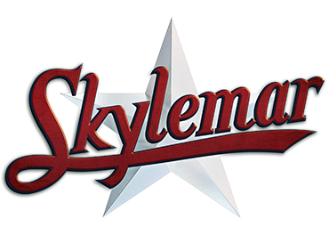Camp Skylemar Nurse Job Description Summer 2024
This is an 8 week residential program in Naples, Maine. Camp Skylemar has been family owned and operated for 75 years. The mission of making a positive difference one boy at a time has been shown over and over in an environment where it’s “cool to care”. Skylemar is a boys camp with approximately 200 campers and 110 adult staff.
Dates: July 12, 2024-August 10, 2024- meals and housing provided.
Hours: Will vary based on day’s activities. Most days are 7:45 am- 10:00 pm. Infirmary staff creates rotational schedule with days off, on-call overnights, and daily breaks.
Salary: starting at $1000 per week dependent on experience and if you are using the scholarship benefit for staff children. Full scholarship for 8 week sessions available for staff children 7-15 years old.
Responsibilities
Reviewing all campers’ medical forms and medication lists on July 7th before their arrival.
Check, distribute and replenish first aid kits throughout camp with supplies as needed. Create medication packets for overnight staff and when campers are off property.
Infirmary Based care includes:·
- Administering camper medications
- Treating Illness and injuries
- Communicating with parents/guardians, staff, and health care providers
- Maintain accurate medical records
Qualifications:
· Registered nurse (RN) with a license as required by that state law.
· Current CPR and First Aid certified
· Experience in first aid and emergency management
· Experience in both children and adult illness/injury care

How to apply:
Please visit www.campskylemar.com for an introduction to Skylemar. For more information please contact the camp director, Arleen Shepherd at 270-698-6414 or arleen@campskylemar.com
·

